Marwadi University

Department of CE/IT

**Practical 1 : Creating Amazon EC2 instances with Microsoft Windows**

Step 1. Go to AWS dashboard and select EC2 in compute.

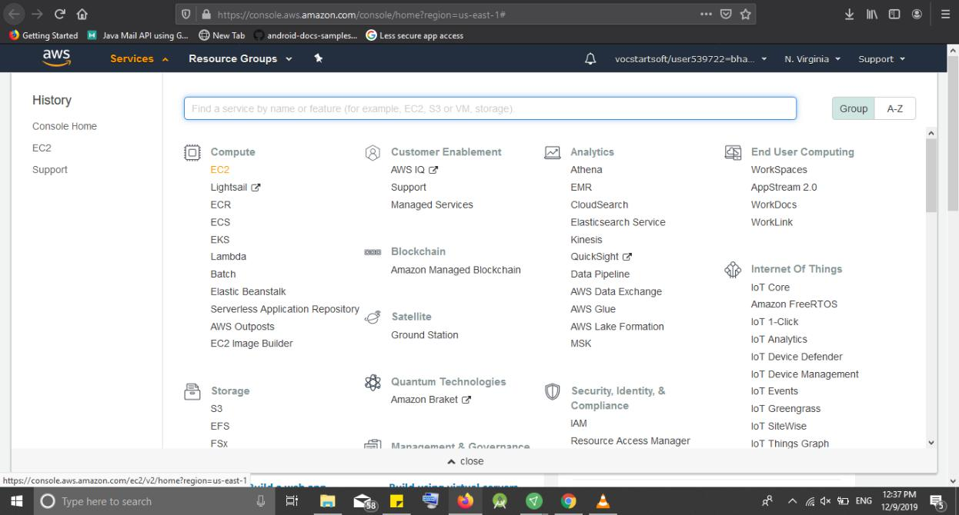

Step 2. Select “Windows 2008 Server Base”

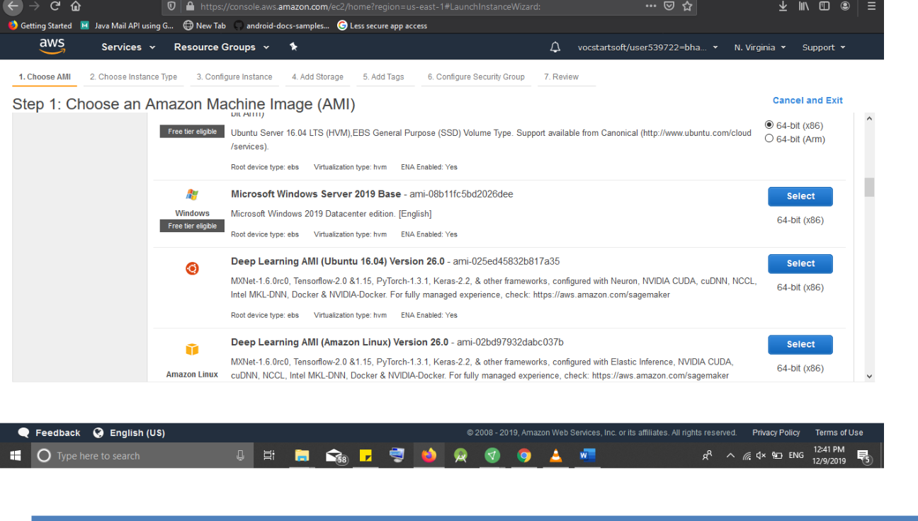

|  |  |
| --- | --- |
|  |  |
|  |

Marwadi University

Department of CE/IT

Step 3. Here select the free tier eligible and then Next.

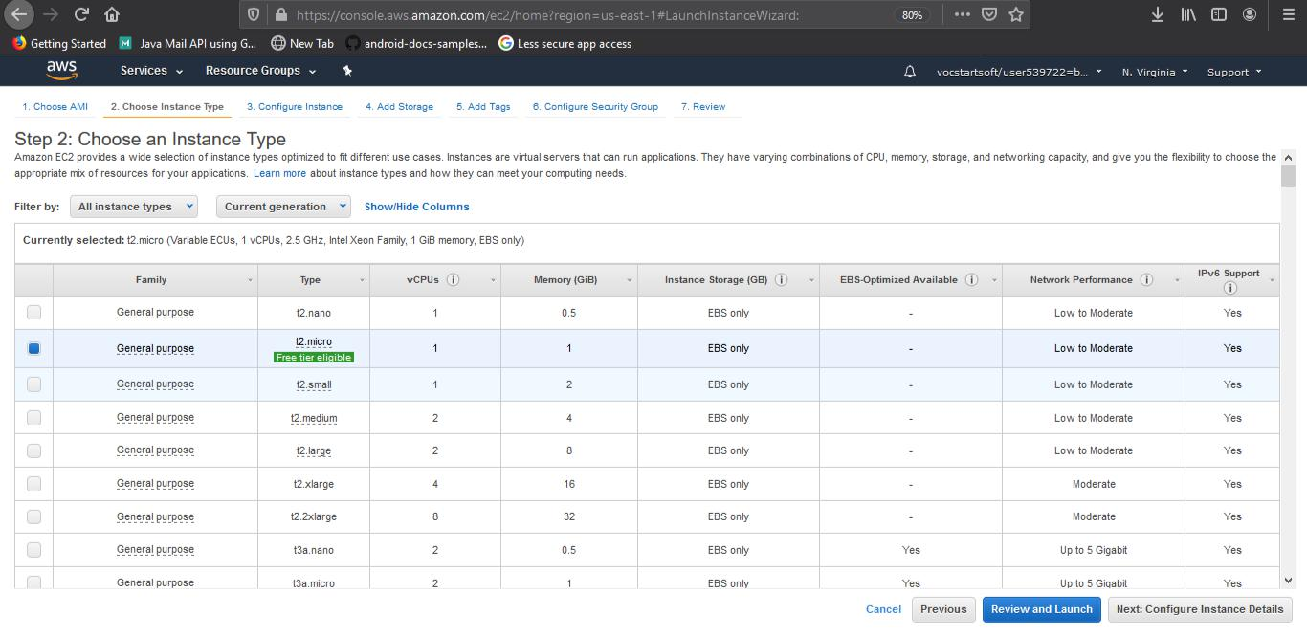

Step 4. Configure Instance Details :

No changes are required just proceed to Next:Add Storage

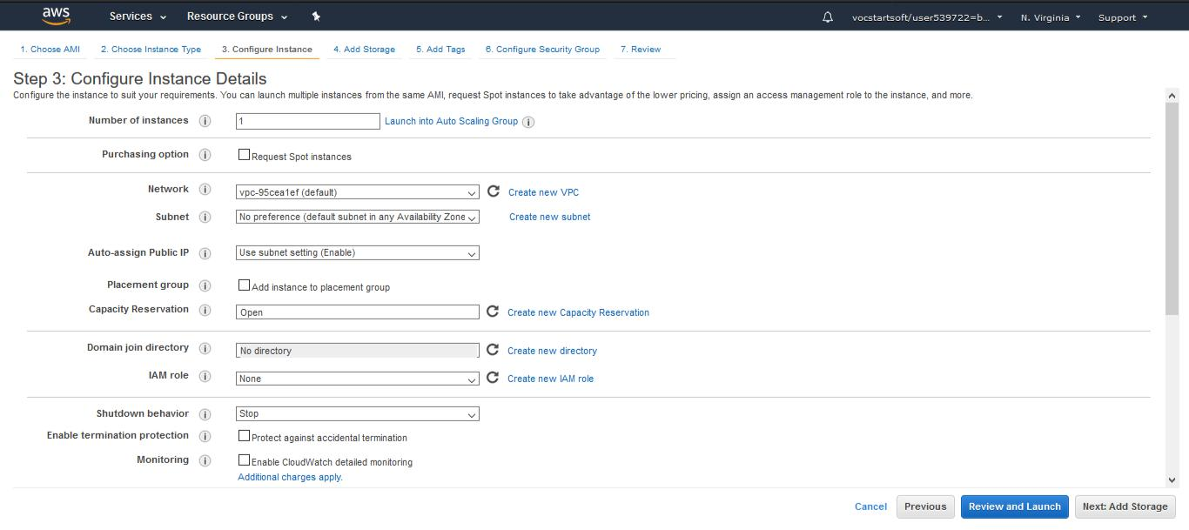

|  |  |
| --- | --- |
|  |  |
|  |

Marwadi University

Department of CE/IT

Step 5. Add Storage:

-No changes required here but if wanted one can change the storage capacity by changing in the size column.

-Click Next: Add Tags

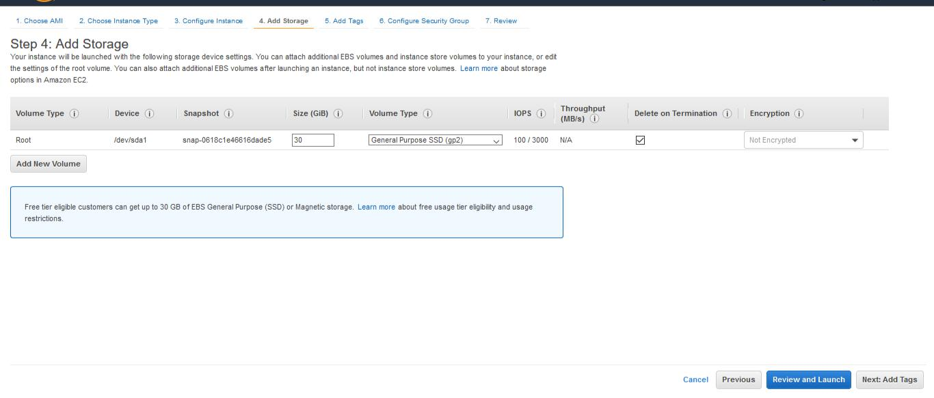

Step 6. Tags:

-In key mention anything and in value specify something to identify such as is it recognizable - Click Next: Configure Security Group

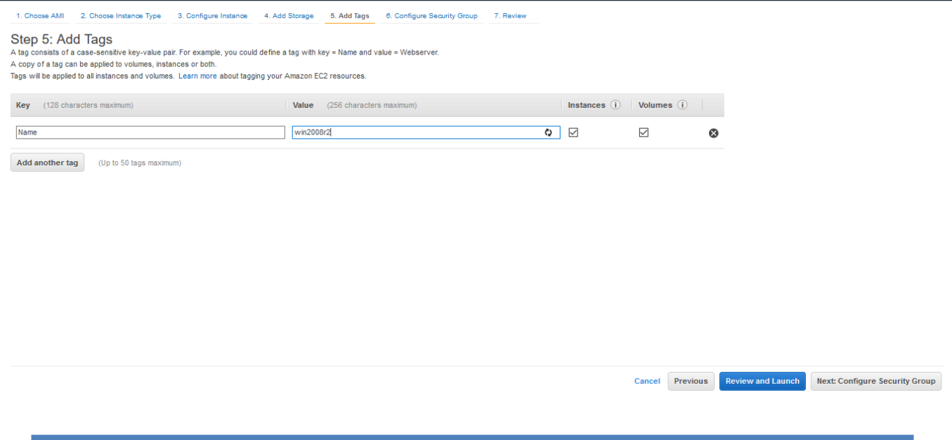

|  |  |
| --- | --- |
|  |  |
|  |

Marwadi University

Department of CE/IT

Step 7. Configure Security Group

* No changes required just proceed towards by clicking on Review and Launch

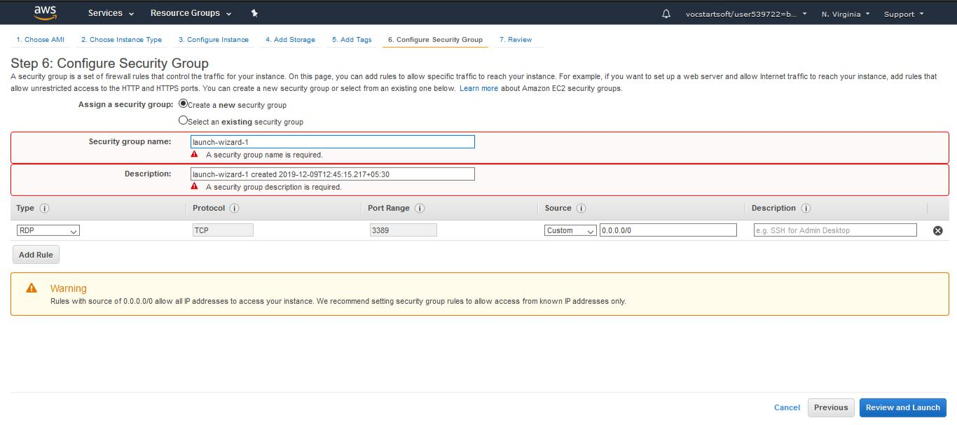

Step 8. Creating Pair key for Remote Desktop

- Go to Dashboard and select the instance which you created just now.

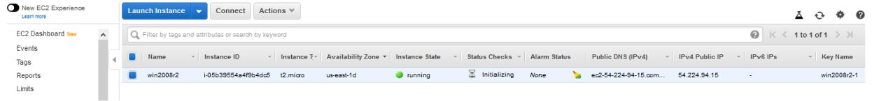

* Click on Connect
* It will show a Dialog box in which you need to select create new Pair Key.
* Mention any key pair name and then download then key pair and save it.
* Launch instance.

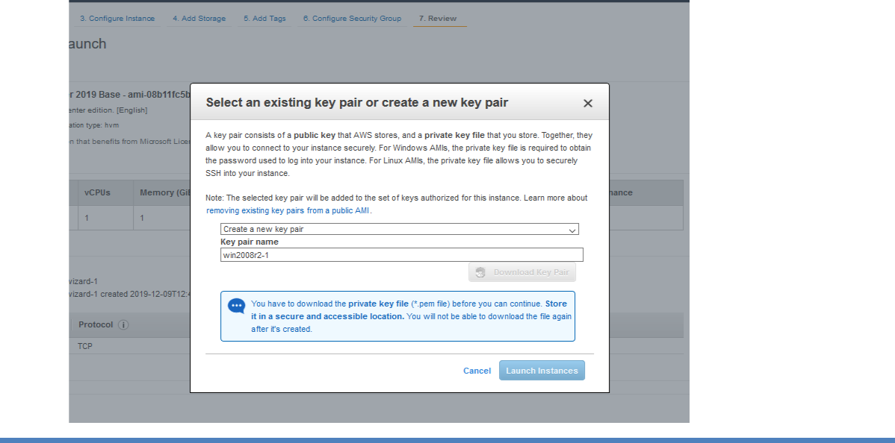

|  |  |
| --- | --- |
|  |  |
|  |

Marwadi University

Department of CE/IT

Step 9. Creating the Remote Desktop

-After key is downloaded dialog box will appear then click on Download Remote Desktop File

-Open the Downloaded File and it will ask for password

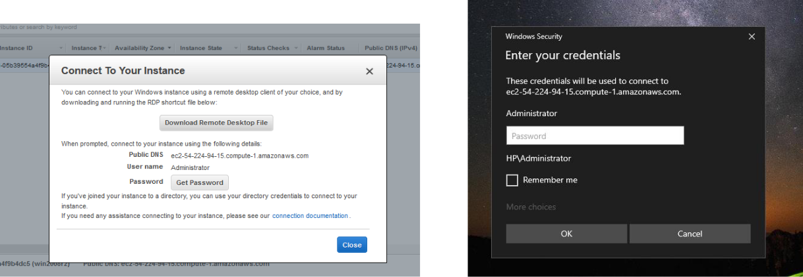

Step 9. Getting Password

* Go to EC2 Dashboard select the DropDown Action button and choose get windows Password.

-Select the previously downloaded pem file and decrypt password.

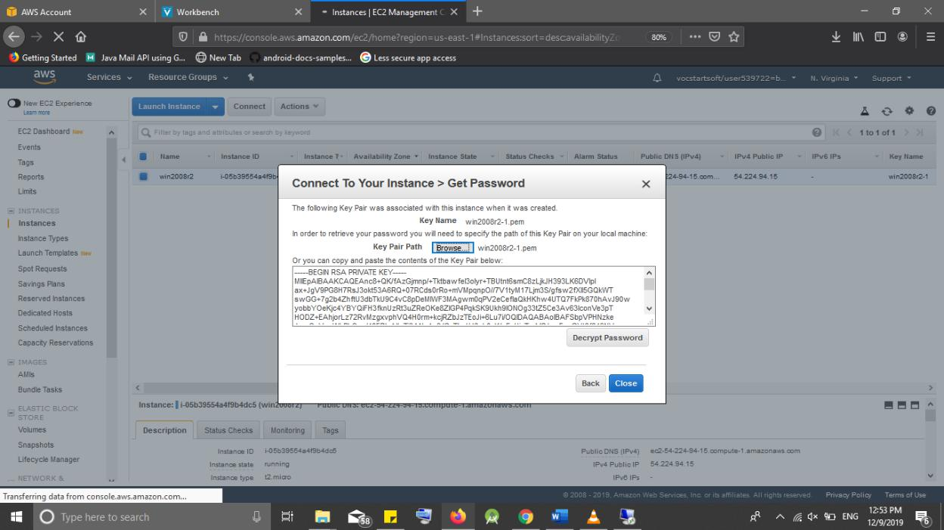

|  |  |
| --- | --- |
|  |  |
|  |

Marwadi University

Department of CE/IT

* Copy the password and paste it in the windows dialog box administrator password

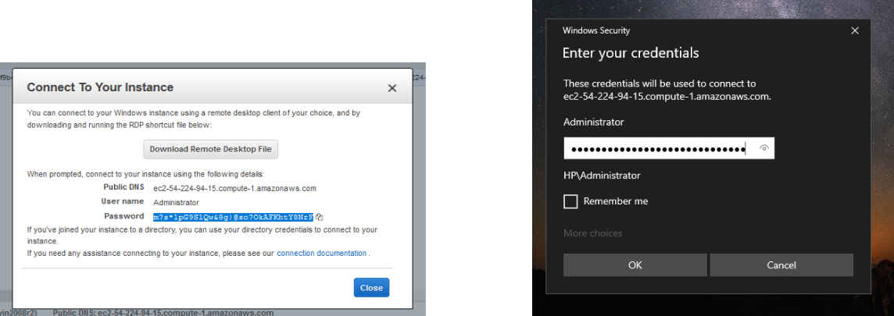

* It will take time to connect

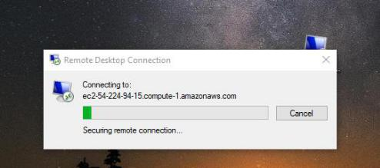

Step 10. Now you can work on the remote version of windows 2008 from your desktop which is running on EC2.

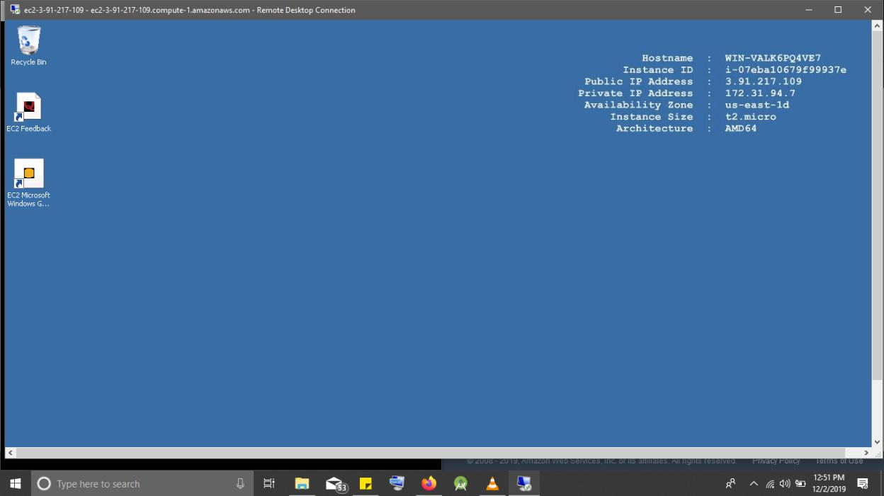

|  |  |
| --- | --- |
|  |  |
|  |

Marwadi University

Department of CE/IT

Step 11. Now after the completion of your work on the virtual machine you need to stop thew instance of it. To do it

* Go to the dashboard and select the instance
* Click on action and select instance state and in the sub menu first stop the VM

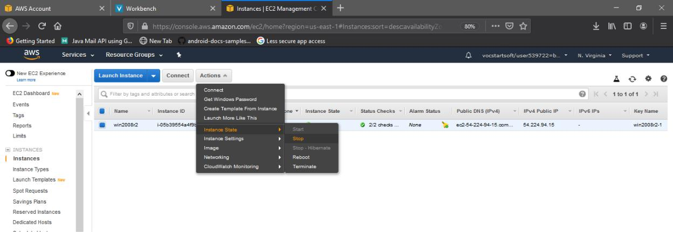

- After the VM is stopped Terminate the VM



    
    
    
  